- Purpose
  - The purpose of this document is to describe the procedure for prepping and checking a Stealth DRS21BT MicroRider machine before shipment.
- Scope
  - This SOP applies to all equipment assembly team members. The process applies to the following machine ID’s:
E029961PKG0600BE1200 – Stealth DRS21BT MicroRider w/2-12V 130AH Wet Bat, 12 Amp Charger
E029962PKG0600BE1200 – Stealth DRS21BT MicroRider w/2-12V 110AH AGM Bat, 12 Amp Charger
E029963PKG0600BE1200 – Stealth DRS21BT MicroRider w/2-12V 155AH Wet Bat, 12 Amp Charger
- Responsibilities
  - The operations manager/supervisor is responsible for enforcing this SOP.
- Materials
  - The proper materials needed for this process are listed on the machine work order.
- Definitions

- Procedure
  - Begin by taking a base machine (29960) out of the box. Set all of the components aside that come with it.

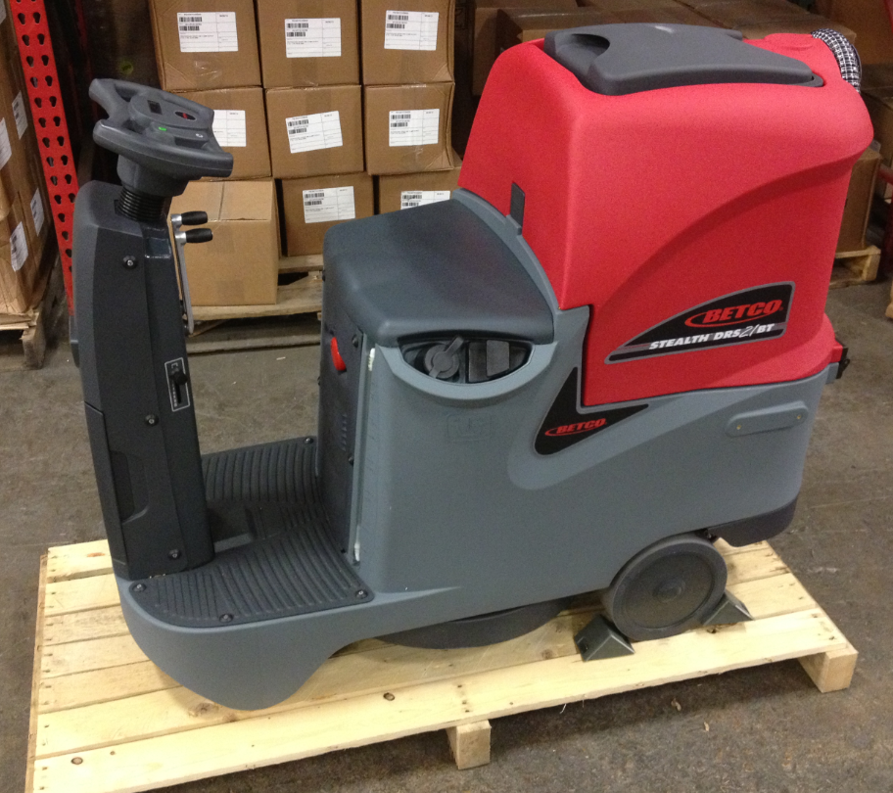

  - Locate the red electronic brake lever behind the right wheel. Lift the lever to release the brake.

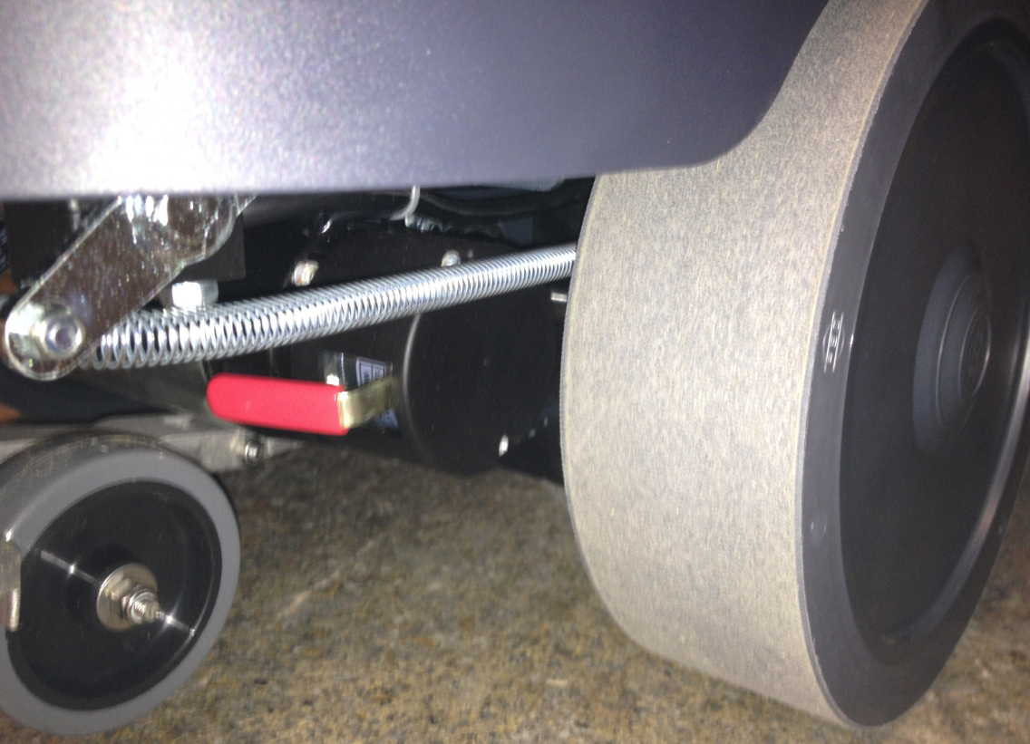
  - Place a ramp onto the pallet behind the machine. Roll the machine onto the floor. Try to lift the machine over the wheel blocks on the pallet so that they can be re-used.
  - Press the button on the seat to release the access cover to the battery compartment. Remove the components in the battery compartment. The filter, the key, and the battery cables should be in there.

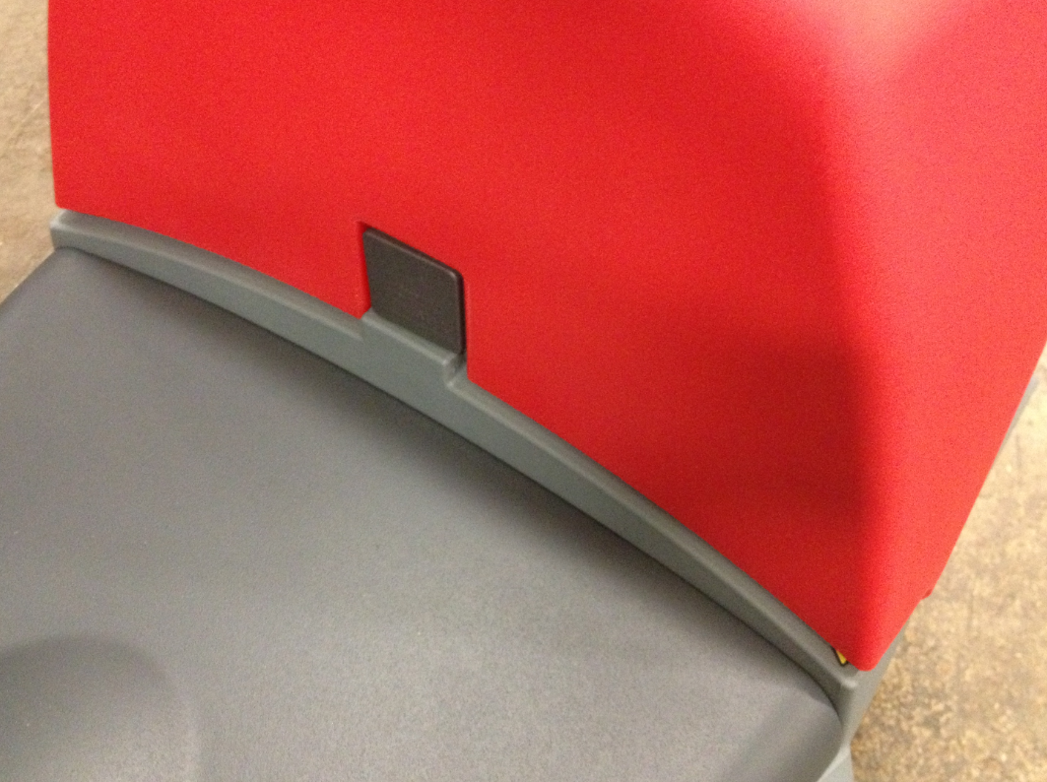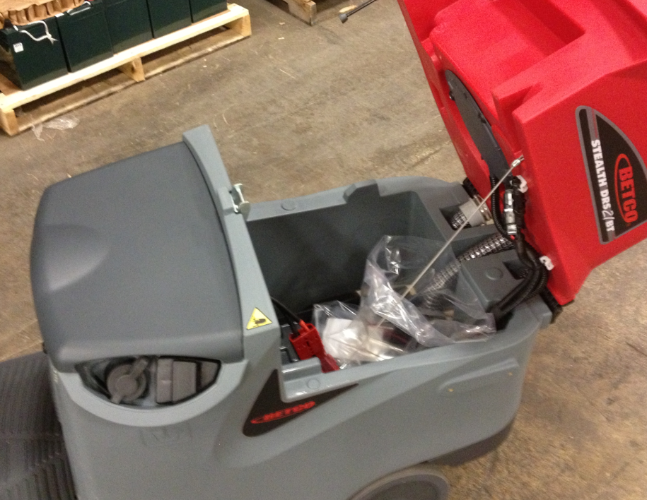

  - Place the key into the keyswitch.

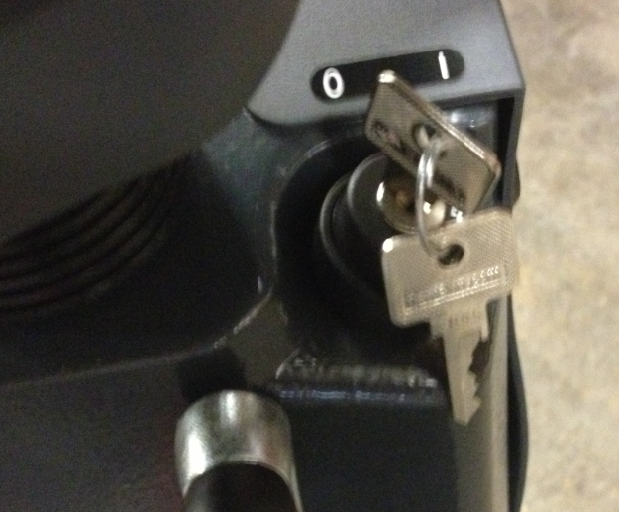

  - Install the filter screen into the housing on the bottom of the machine under the drivers left foot. Once the screen is in place, thread the cap on until it is tight.

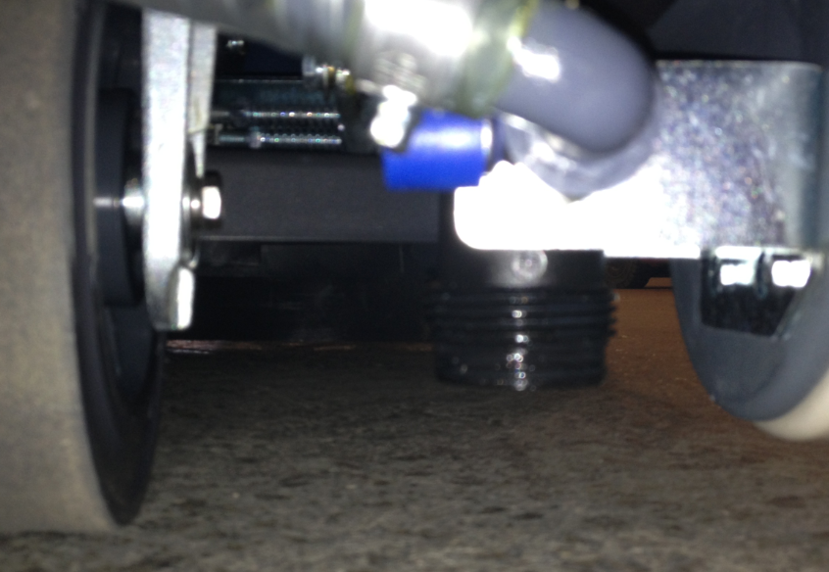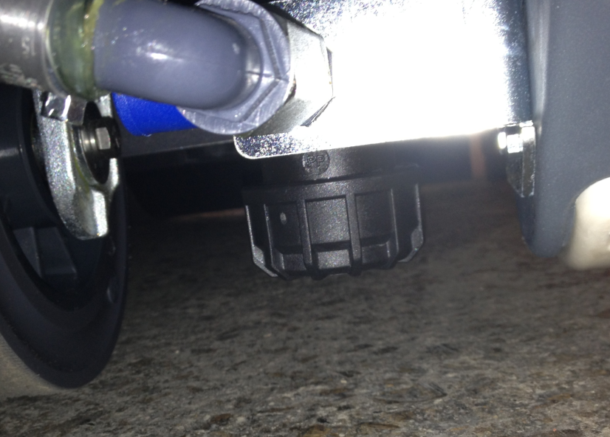
  - Place 2 batteries into the battery compartment in the orientation shown. Reference the work order to know which batteries to use. (11767 or 20700 for wet cells and 88030 for AGM) For AGM batteries, place a Maintenance Free Battery Decal (88897) onto each battery.

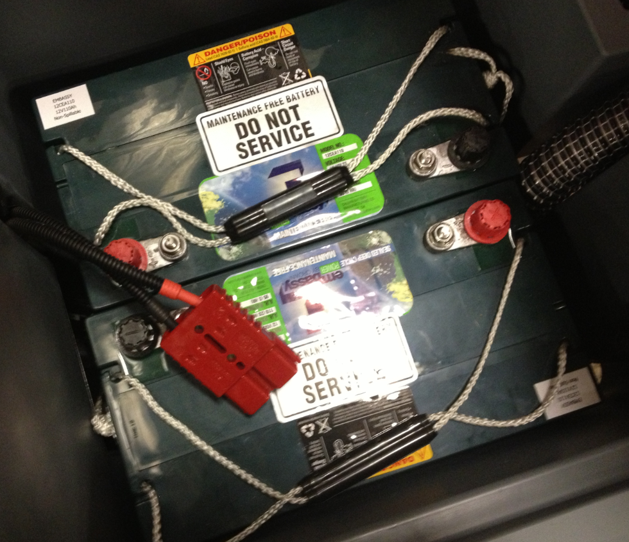

  - Use the cables provided to wire the machine. Spray some terminal protector onto the terminals before putting the covers into place. Use the photo as a template.

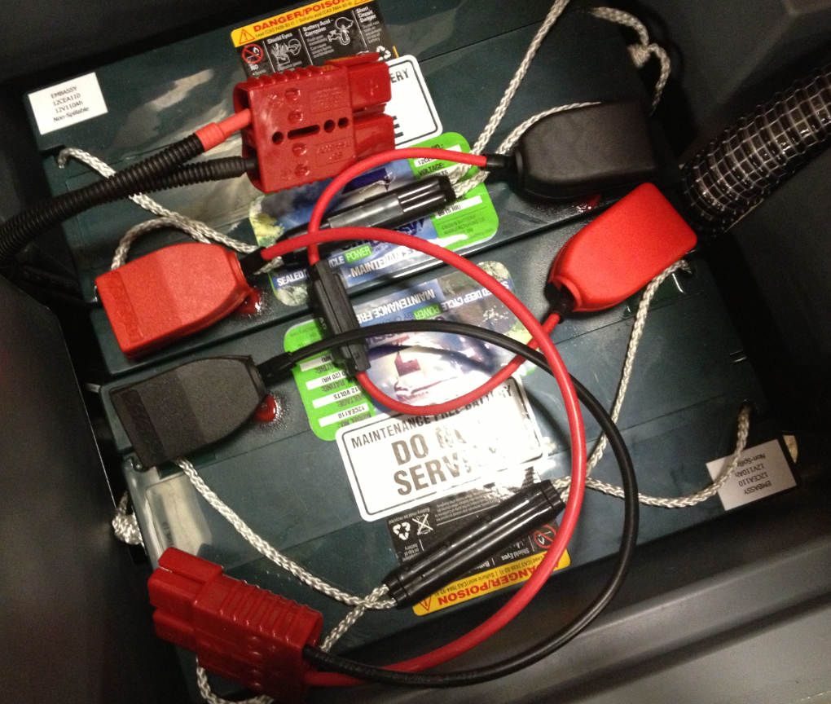
  - Connect the pigtail from the batteries to the machine. Close the battery compartment.

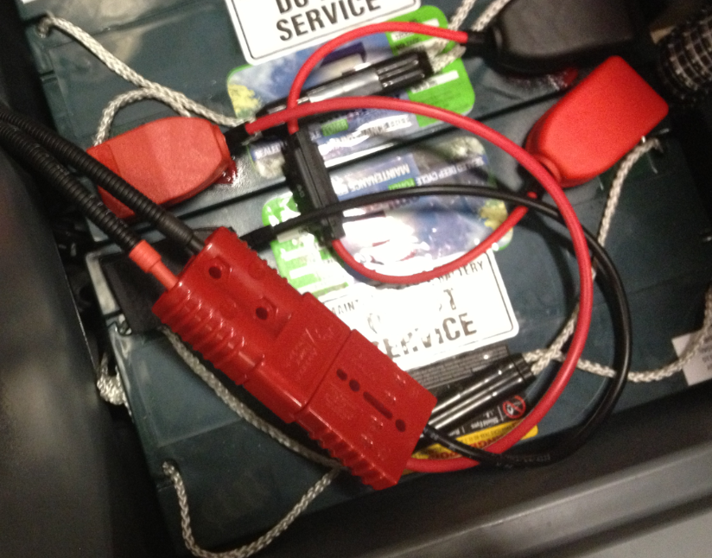

  - Lower the red electronic brake lever. This will activate the electronic brake. The brake must be on to drive the machine.
  - If the machine has wet batteries, proceed to step 5.13.
  - If the machine is equipped with AGM batteries, the machine settings need to be changed at this point.
-Start with the keyswitch in the “off” position.
-Press the horn button, the forward/reverse button, and the brush couple/uncouple button at the same time. While holding those buttons down, turn the keyswitch to the “on” position. Continue holding the buttons down until the machine enters programming mode.
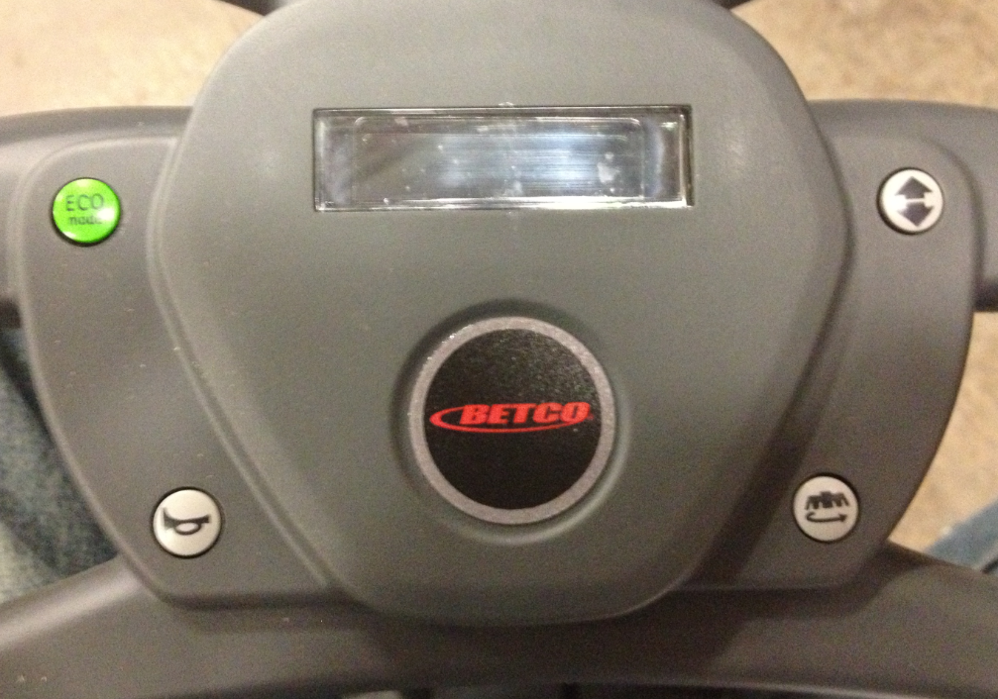
-Once in programming mode, the horn button functions as an enter key while the forward/reverse button and the brush couple/uncouple button function as the scrolling keys.
-Scroll through the setting options on the screen until the battery setting page shows.
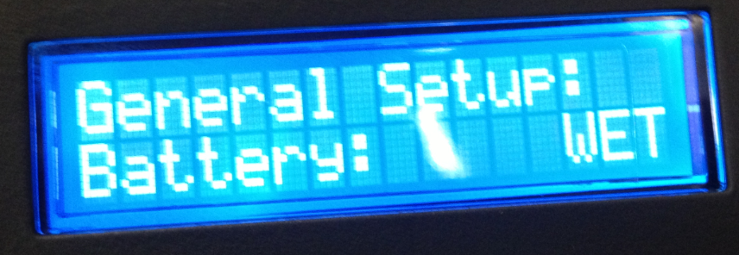
-Once at that screen, press the horn button to enter the battery settings. It should flash once this happens.
-Scroll through the battery types until “AGM” appears on the screen. Once it does, press the horn button to select it.
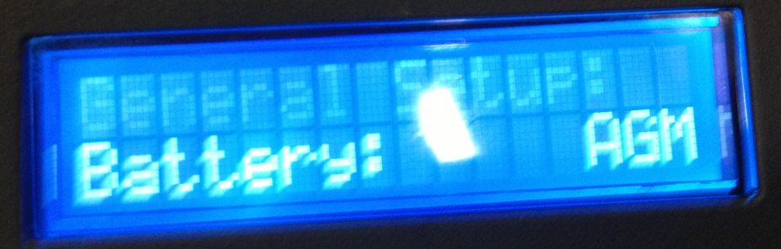
-After the horn button is pressed, the selected battery type should be displayed on the screen.
-Continue scrolling through the machine setting pages until you get to the “Exit” page.
-Press the horn button to select this. The machine will then exit programming mode and proceed to the machine main display.
-Turn the machine off.
  - Turn the keyswitch to the “On” position. Watch the screen and verify that the proper battery type is chosen. Do this even if the setting was just changed to AGM. Also verify that the proper language has been chosen for the machine. If is needs changed, enter programming mode and change it by using some of the same functions that were used to change the battery settings.

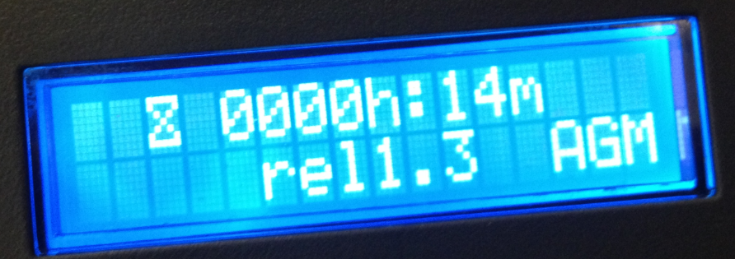

  - Verify that the traction motor operates properly. Make sure that it goes forwards and backwards, verify that the speed is adequate, verify there are no improper noises or vibrations, verify that the reverse beep operates, etc.
  - Pour approximately 3 gallons of washer fluid into the machine solution tank.

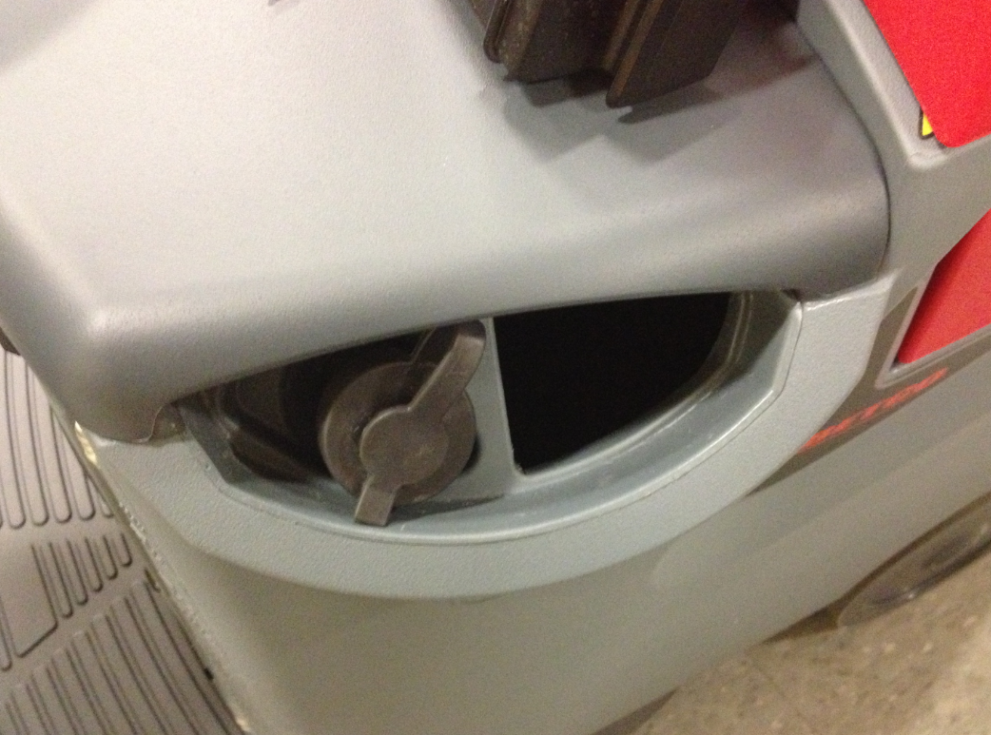

  - Lower the squeegee and the scrub deck and listen to make sure that the vacuum motor on the machine comes on. Check the suction by placing your hand over the end of the vac hose. Press the “ECO” button on the steering console and listen to make sure that the vacuum motor noise decreases. If so, press the button again to return it to full power. Raise the squeegee and the scrub deck. The vacuum motor will turn off after a few seconds.

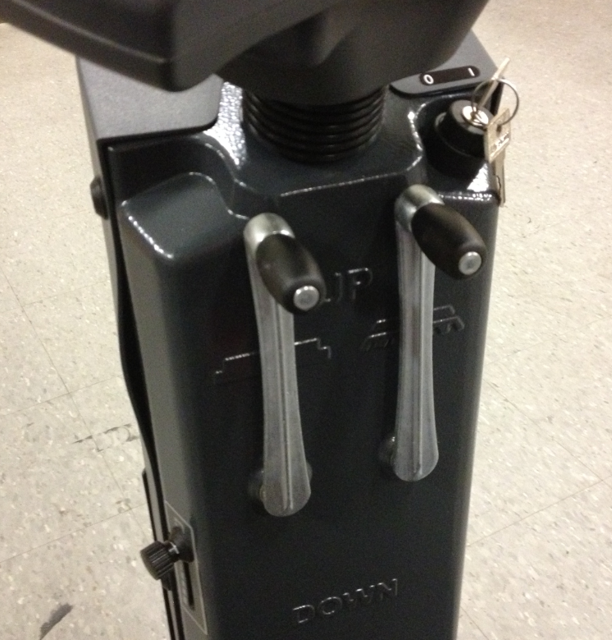

  - Place the test brush for the machine under the scrub deck. Use the lever to lower the deck onto the brush. Gently press the accelerator pedal and the machine should engage the brush. If the machine does not, verify that the brush is centered and try again.
  - Drive with the brush engaged to make sure it does not fall off or work improperly.
  - If all checks out well, raise the scrub deck so that the brush can be dropped off.
  - With the scrub deck all the way up, press the brush couple/uncouple button. A message will appear saying “Unlock?”. Once that shows up, press the button again and the machine should automatically drop the brush. If it does not, check to see if an adjustment needs to be made to the clutch plate on the bottom of the machine. If all checks out well, put the brush away.

  - Using the lever on the side of the machine, turn the solution flow all the way on.

  - Lower the scrub deck about low enough so that when the accelerator pedal is pressed, the solenoid can be heard clicking. This should be an audible noise. Drive the machine until fluid starts dropping onto the floor. If fluid does not flow, try adding some more. If fluid continues to not flow, diagnose the problem and correct it.
  - Take the machine back to its pallet. The machine has passed inspection.
  - Turn the machine off and release the brake by pressing the lever up.
  - Before loading the machine back onto the pallet, screw a 2x4 under where the front wheel goes to reinforce the pallet.

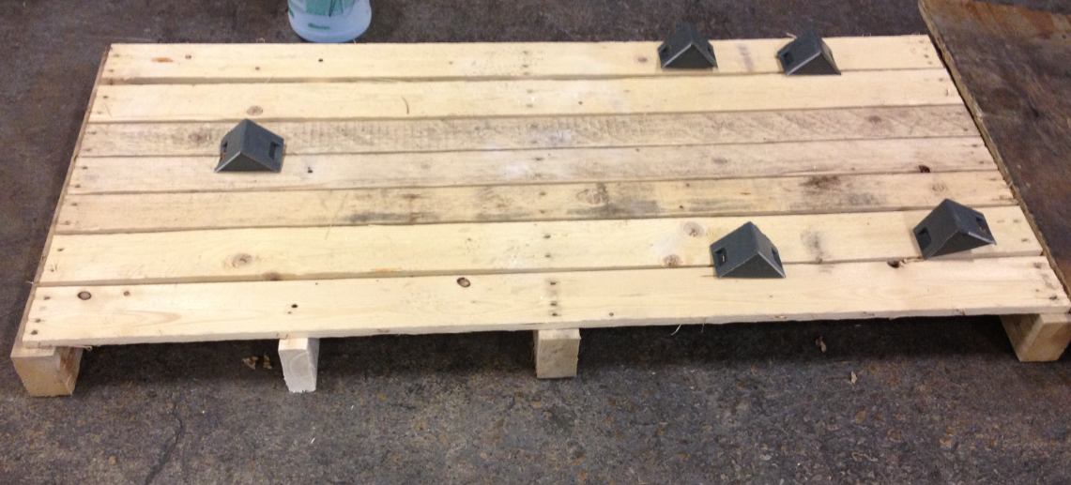

  - Pull the machine back onto the pallet in the same orientation as when it was removed. Try to lift the machine over the blocks so that they can be reused. If any of the blocks were damaged or came off, either re-attach them or use wood blocks to secure that machine.

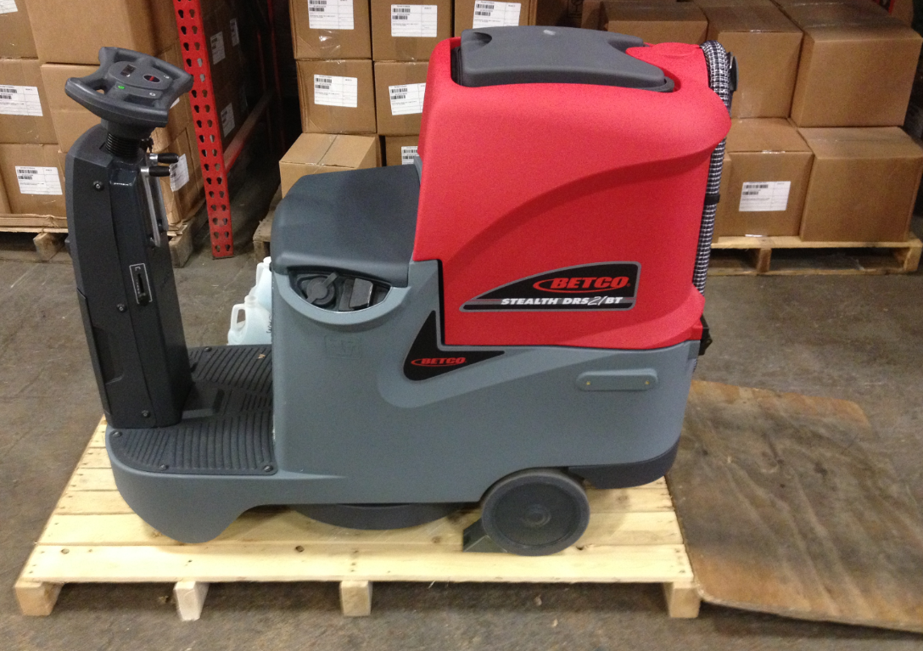

  - Once the machine is in position, re-engage the brake and turn the key to the “off” position if it hasn’t been done already.

  - Place a yellow “QC” tag onto the machine as shown.

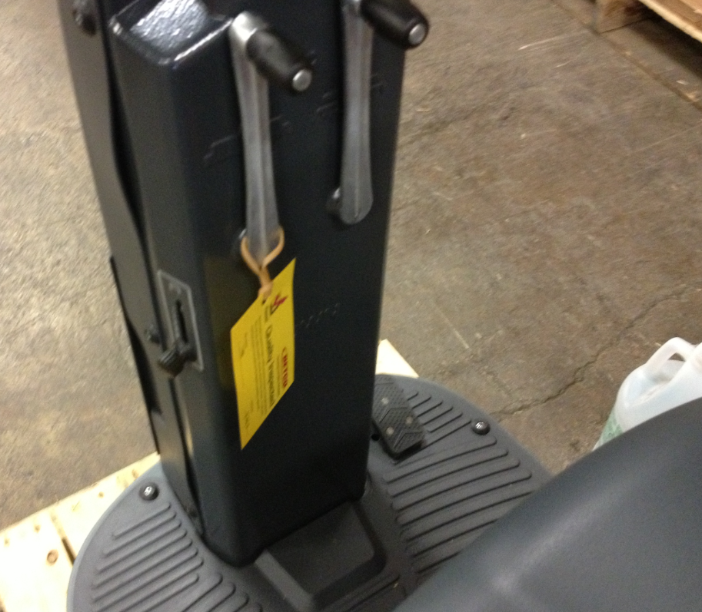

  - Lower the scrub deck and locate the solution tank drain hose. Drain the remaining fluid from the machine into a pan. Once the machine is empty, be sure the close the valve and place it back onto the scrub deck.

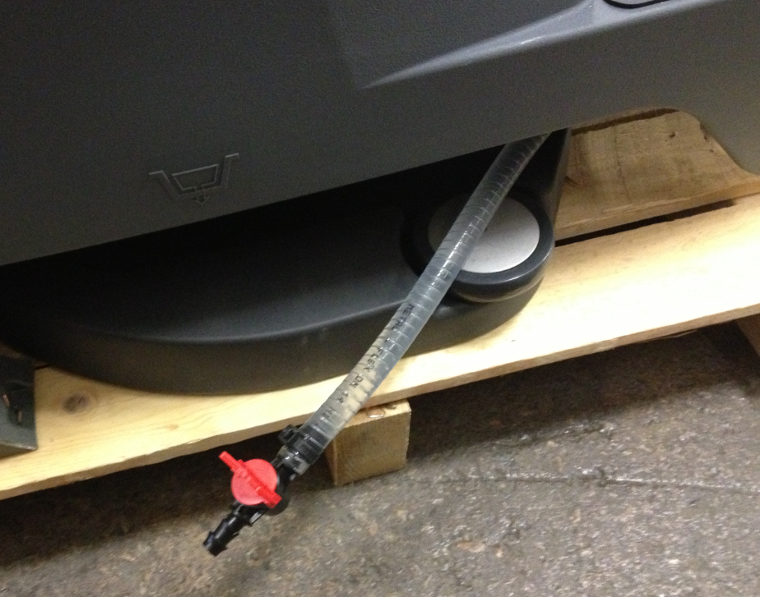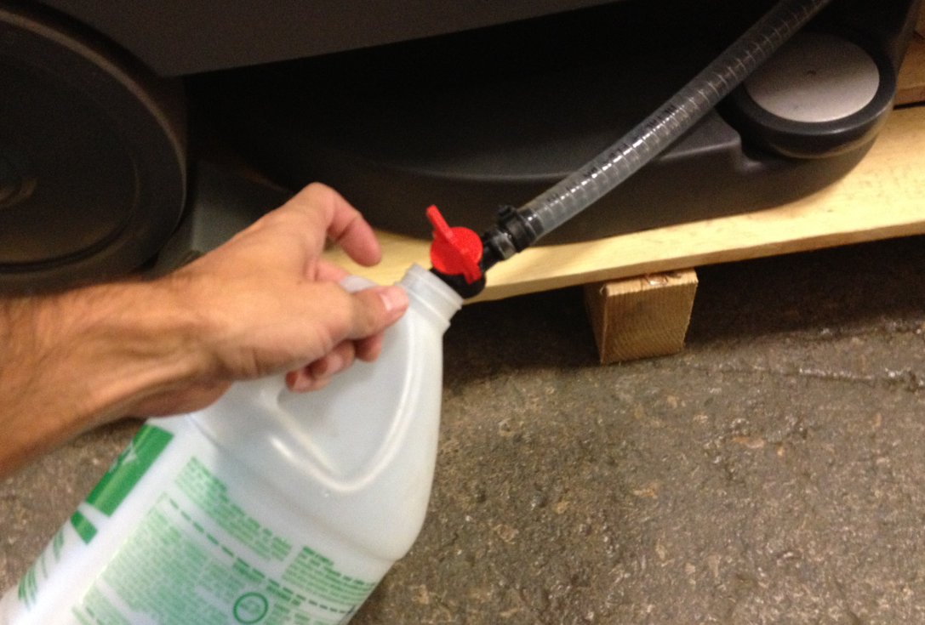

  - Raise the deck enough so that the provided foam insert can be placed under it. Finally lower the deck back onto the insert.

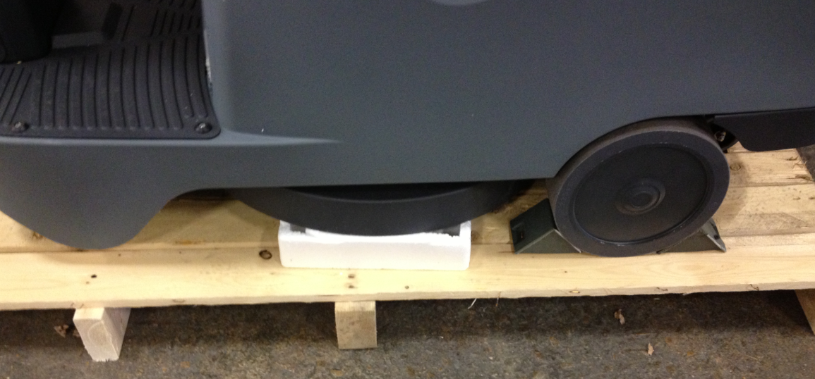
  - Open the battery compartment and disconnect the battery pigtail.

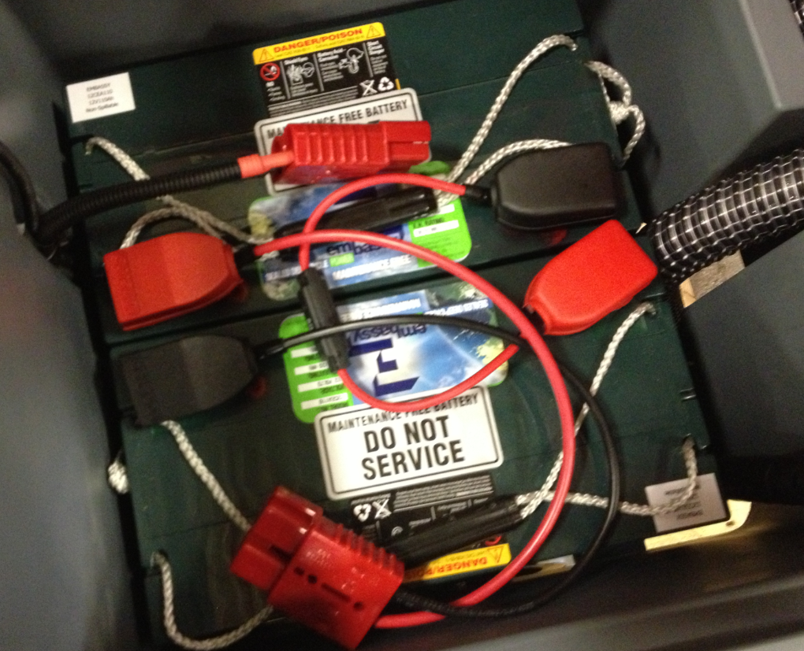

  - Place two bands on the machine to hold it securely to the pallet. One goes on the front of the machine on the floor and the other goes over the battery compartment. Close the battery compartment when complete.

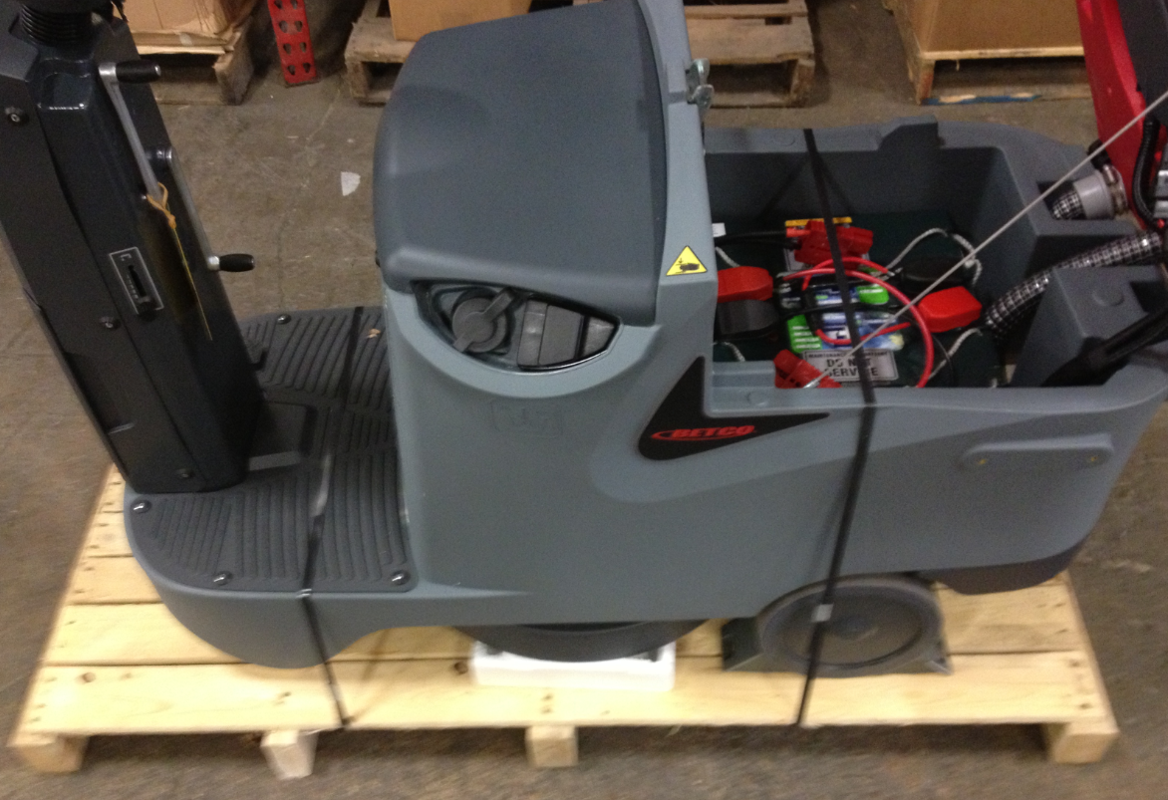

  - Put a manual packet together that includes a manual and a warranty card. Remove the key from the machine and place it into the bag.
  - Place a machine cover (89836) over the machine.

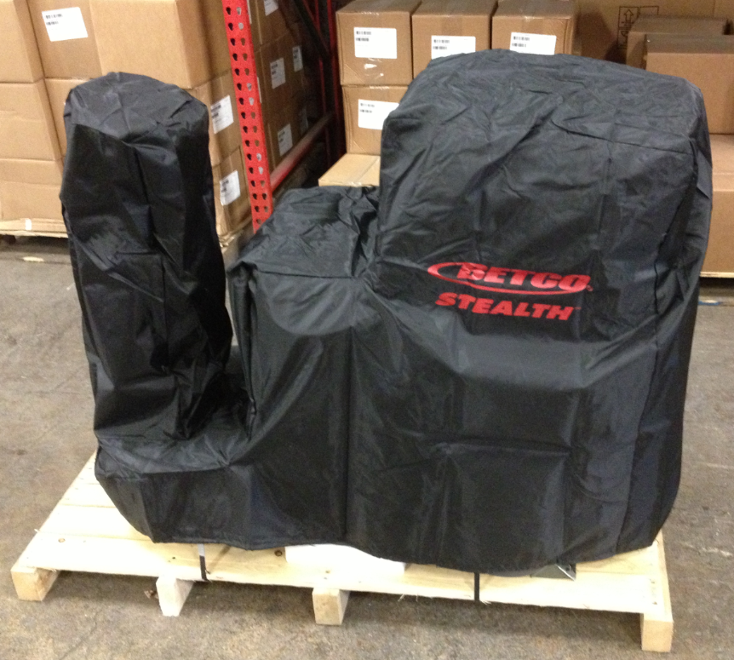

  - Place the plastic bag that the machine came in back over it.
  - Place the pad driver and the squeegee onto the machine in the location shown.
  - Set the needed charger (88128) onto the seat of the machine. Place the manual packet onto the charger box and tape it in place. Secure all of the components with tape.

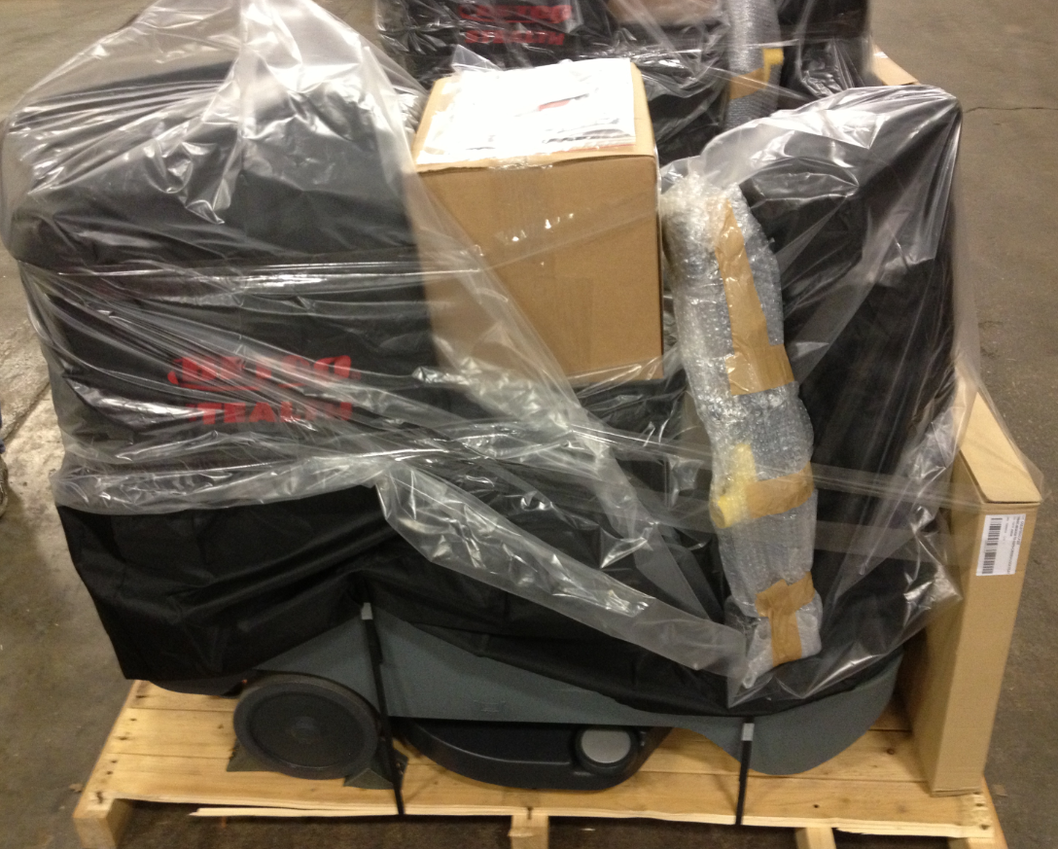
  - Place the shipping box back over the machine. Once the box is positioned properly, use 2 bands to secure it to the pallet.

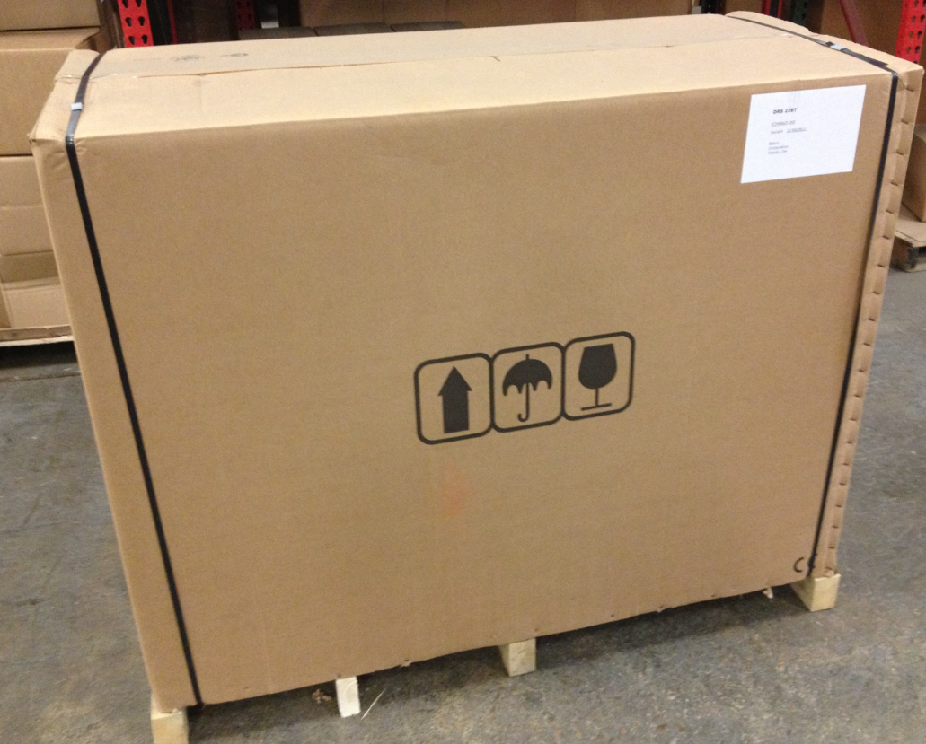

  - Place a machine ID sticker in the locations shown. They should cover up the old ID number of the machine. Also, place a UN3171, Battery Powered Equipment Sticker (RLB016AV1) onto the front side of the box.

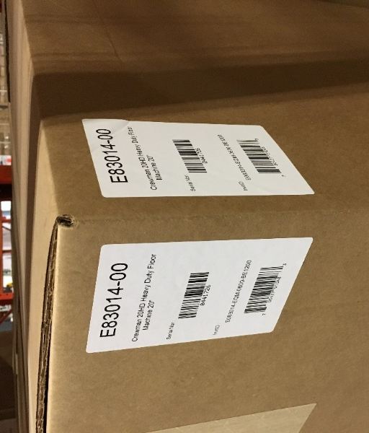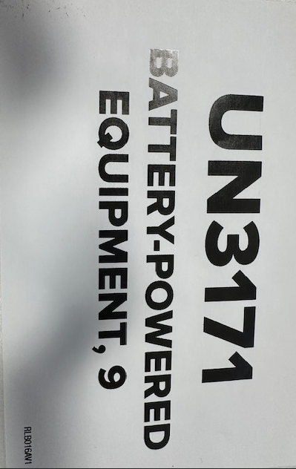

  - The machine is now ready for shipment.

- References (optional section as needed)

- Training Guide

Functional Training Groups Requiring Training
Equipment Group

- SOP Change Control

Date of Change | Reason for Change
Rev 01 | This is the first version of the S.O.P. hence there are no revisions to this document.
Rev 02 - 1/26/2018 | Added the Responsibilities Section
Rev 03 – 12/5/2025 | Added Battery Powered Equipment sticker onto outside of box

Approvals

Submitter/Author Approval:__________________________________ Date:______________________

Management Approval:______________________________________ Date:______________________

QAU Approval:_____________________________________________ Date:______________________

